***SHRIMATI INDIRA GANDHI COLLEGE, THIRUCHIRAPPALLI***

**DEPARTMENT OF MATHEMATICS**

**NAAN MUDHALVAN PROJECT REPORT**

**Project partner: Smart Internz Class:III B.Sc (MATHEMATICS) Project by: Data Literacy with Tableau Team ID: NM2023TNIDO4656**

**INDIA’S AGRICULTURAL CROP PRODUCTION ANALYSIS (1997-2021)**

**INTRODUCTION OVERVIEW:**

we delve into the vibrant and diverse world of India's agricultural crop production. India, known as the 'Land of Agriculture,' is a country with a rich agricultural heritage that spans millennia. With its vast geographical and climatic diversity, India is one of the world's leading agricultural producers, contributing significantly to global food security. Here we will explore the key crops, the factors that drive agricultural production, and the challenges and innovations that shape the industry in India. From the traditional practices that have been passed down through generations to the modern agricultural technologies revolutionizing the sector, India's agricultural crop production is a compelling narrative of tradition meeting innovation. And learn about staple crops, and understand the significance of agriculture in India's socio-economic landscape. Welcome to the world of India's agricultural abundance."

**PURPOSE:**

The agricultural crop production in India serves a crucial array of purposes deeply intertwined with the nation's socio-economic fabric. Foremost, it endeavors to ensure food security for its vast populace, striving to meet the dietary needs of millions. Simultaneously, agriculture stands as a linchpin of economic livelihood, offering employment to a substantial fraction of the workforce, both directly and indirectly. This sector holds a pivotal position in the Indian economy, contributing significantly to the Gross Domestic Product (GDP) and fostering growth across various related industries.

**PROBLEM DEFINITION AND DESIGN THINKING:**

**EMPATHY MAP:-**

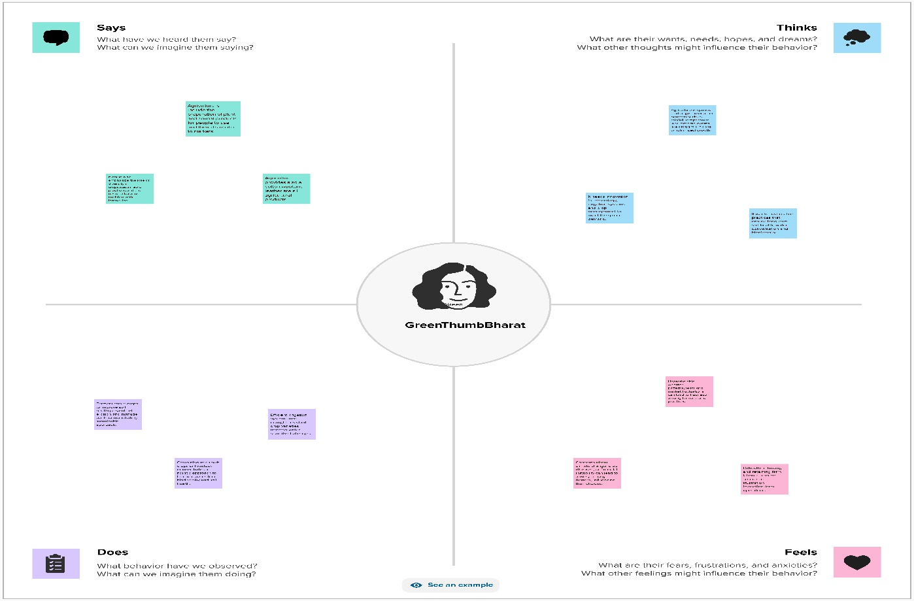

**BRAIN STROMING MAP :-**

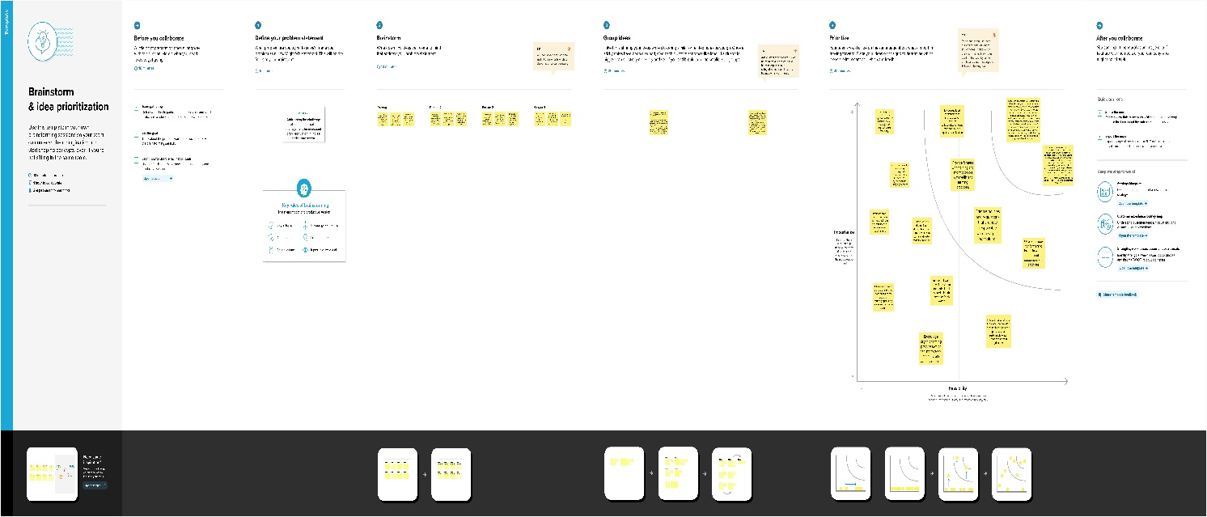

**RESULT:** 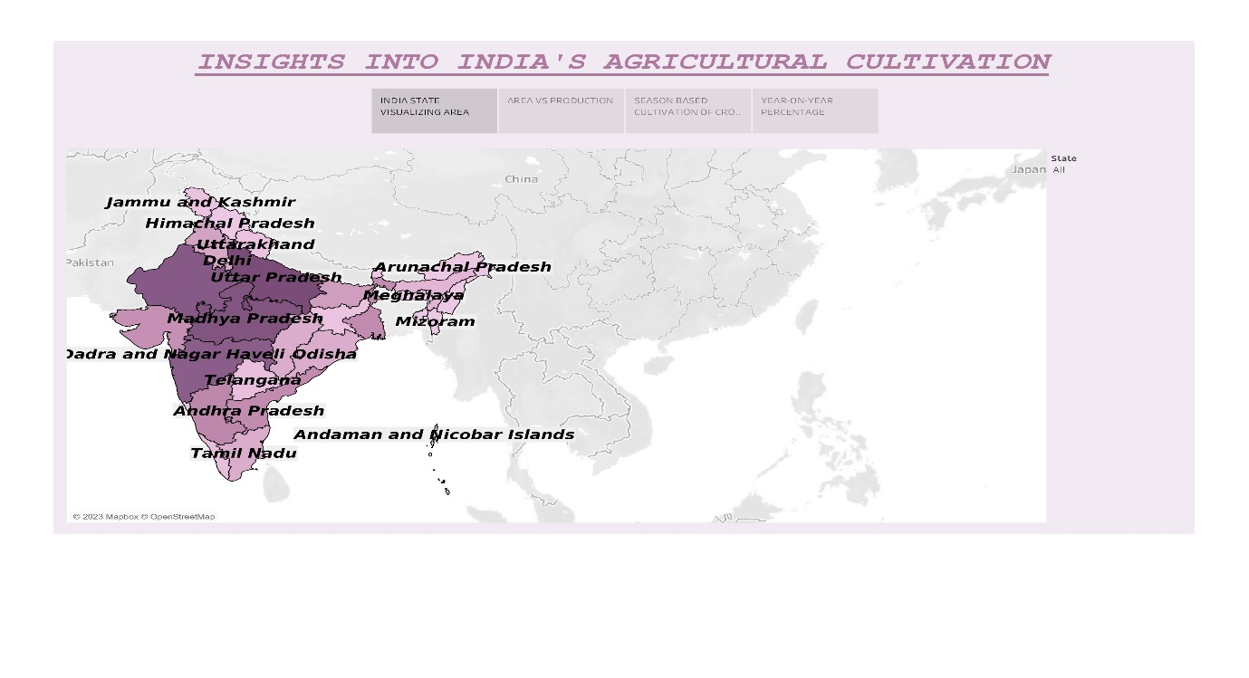

In this project, we conclude that the State wise Agricultural Land, Area -Vs- Production, Season based cultivation, Area, and major crops

**ADVANTAGES:**

* **Diverse Agro-climatic Zones:** India's geographical diversity allows for year-round cultivation of a wide variety of crops.
* **High Crop Yield:** Improved farming practices and technology have led to increased crop yields.
* **Rich Biodiversity:** Natural pollinators and pest control from India's biodiversity support sustainable agriculture.
* **Large Labor Force:** The availability of a large labor force supports labor-intensive farming practices.
* **Export Potential:** India is a leading exporter of agricultural products, contributing to its economy.

**DIS ADVANTAGES:**

* **Water Scarcity:** Many regions in India face acute water shortages, affecting crop irrigation and overall agricultural productivity.
* **Fragmented Land Holdings:** The division of agricultural land into small, fragmented plots can lead to inefficiencies in farming and reduced economies of scale.
* **Dependency on Monsoons:** A significant portion of India's agriculture depends on the monsoon rains, making it vulnerable to erratic rainfall patterns and droughts.
* **Pesticide and Fertilizer Misuse:** Overuse and misuse of pesticides and chemical fertilizers can have negative environmental and health impacts.
* **Post-Harvest Losses**: Inadequate storage and transportation infrastructure lead to significant post-harvest losses of crops, impacting food security and farmer income.

**CONCLUSION :**

India's agricultural crop production is marked by both advantages and challenges. Its diverse agro-climatic zones, high crop yields, and rich biodiversity contribute to its agricultural strength.

However, the sector faces issues such as water scarcity, fragmented land holdings, and overuse of pesticides. It is imperative to address these challenges while leveraging the strengths to ensure sustainable growth in Indian agriculture.

**FUTURE SCOPE:-**

There will be more of vertical and urban farming and there will also be efforts in long term to find new areas for production like barren deserts and seawater.

Hydroponic farming, which is a soil-less, water-based farming operation, that may even be done in a tiny space is going to pick up the pace.

**APPENDIX:-**

**SOURCE CODE**

https://public.tableau.com/app/profile/harini.priya.s/vizzes